**Introduction**

In general,a **temperature sensor**is a device which is designed specifically to measure the hotness or coldness of an object.**LM35** is a precision IC temperature sensor with its output proportional to the temperature (in °C).With LM35,the temperature can be measured more accurately than with a thermistor. It also possess low self heating and does not cause more than 0.1 °C temperature rise in still air. The operating temperature range is from **-55°C to 150°C**.The LM35’s low output impedance,linear output, and precise inherent calibration make interfacing to readout or control circuitry especially easy.It has find its applications on power supplies,battery management,appliances,etc.click [**here**](https://wiki.eprolabs.com/index.php?title=File:SEN-0001.pdf) for datasheet.

**LM35 Temperature Sensor**

[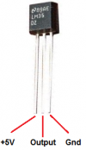](https://wiki.eprolabs.com/index.php?title=File:LM35.png)

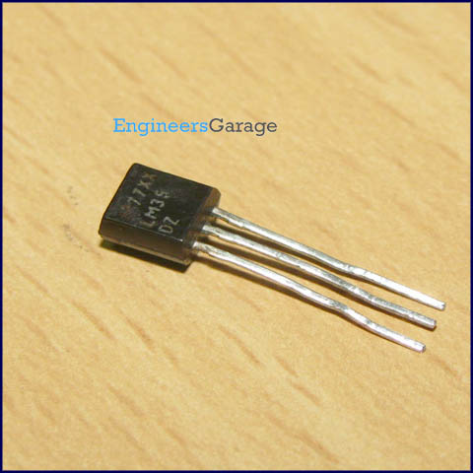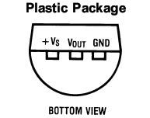

**LM35 Temperature sensor Pinout**

The LM35 is an integrated circuit sensor that can be used to measure temperature with an electrical output proportional to the temperature (in °C).It can measure temperature more accurately than a using a thermistor. The sensor circuitry is sealed and not subject to oxidation.The LM35 generates a higher output voltage than thermocouples and may not require that the output voltage be amplified.The LM35 has an output voltage that is proportional to the Celsius temperature.The scale factor is .01V/°C.

The LM35 does not require any external calibration or trimming and maintains an accuracy of +/-0.4°C at room temperature and +/-0.8°C over a range of 0°C to +100°C.Another important characteristic of the LM35 is that it draws only 60 micro amps from its supply and possesses a low self-heating capability.The LM35 comes in many different packages such as TO-92 plastic transistor-like package,T0-46 metal can transistor-like package,8-lead surface mount SO-8 small outline package.

**Working Principle of LM35**

[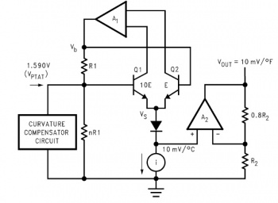](https://wiki.eprolabs.com/index.php?title=File:Lm34_circuit_diagram.jpg)

There are two transistors in the center of the drawing. One has ten times the emitter area of the other. This means it has one tenth of the current density, since the same current is going through both transistors. This causes a voltage across the resistor R1 that is proportional to the absolute temperature, and is almost linear across the range.The "almost" part is taken care of by a special circuit that straightens out the slightly curved graph of voltage versus temperature.

The amplifier at the top ensures that the voltage at the base of the left transistor (Q1) is proportional to absolute temperature (PTAT) by comparing the output of the two transistors.

The amplifier at the right converts absolute temperature (measured in Kelvin) into either Fahrenheit or Celsius, depending on the part (LM34 or LM35).The little circle with the "i" in it is a constant current source circuit.

The two resistors are calibrated in the factory to produce a highly accurate temperature sensor.

The integrated circuit has many transistors in it -- two in the middle, some in each amplifier, some in the constant current source, and some in the curvature compensation circuit. All of that is fit into the tiny package with three leads.

**LM35 Features**

* Calibrated directly in o Celsius (Centigrade)
* Linear + 10.0 mV/oC scale factor
* 0.5oC accuracy guaranteeable (at +25oC)
* Rated for full −55o to +150oC range
* Suitable for remote applications
* Low cost due to wafer-level trimming
* Operates from 4 to 30 volts
* Less than 60 µA current drain
* Low self-heating, 0.08oC in still air
* Nonlinearity only ±1⁄4oC typical
* Low impedance output, 0.1 Ω for 1 mA load